**Pangbourne Community Energy**

West Berkshire Council declared a climate emergency on 2nd July 2019 with the aim that West Berkshire should be carbon neutral by 2030. They published a draft environment strategy where they asked for feedback in order to develop a strategic plan that will work towards carbon neutrality in the district by 2030.

Communities such as Pangbourne are seen as key players in reaching this target. One way to assist the Council in its aim is by setting up a community energy scheme and install solar panels on suitable public and commercial buildings in and around Pangbourne. A number of PAWS members met in February to discuss the idea. 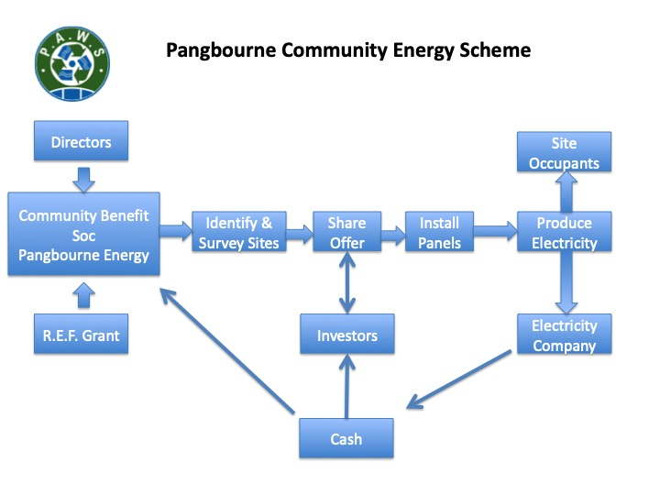

A Community Benefit Society could be set up with a grant from the Rural Energy Fund. Sites would be identified, mostly public and commercial buildings, and then surveyed to check their suitability. A share offer would raise the capital to pay for the panels and their installation. There would be no cost to the owner of the building or the tenants. The electricity would be provided to the occupants at a cheap rate and the remainder sold to one of the power companies. The money from selling the electricity would be used to pay the investors and the surplus used for community benefit. We are at a very early stage and have not yet developed any financial models.

Schemes already exist nearby; Reading Community Energy, MaidEnergy in Maidenhead, Low Carbon Hub in South Oxfordshire and Calleva Community Energy in Aldermaston.

In order to save time and money in setting up a new group one way forward would be to work with one of the established groups that has the experience and knowledge of running a scheme. Of course it would be important to ensure that any community benefit came back to Pangbourne.

With everything on hold at the moment, we hope to carry on looking at setting up a community energy scheme later in the year.

You can keep up to date with PAWS on our new Facebook page.

PAWS (Pangbourne & Whitchurch Sustainability)