Report to PAWS AGM 14th May 2020

**Biodiversity**

The following activities and events were organised during the past year:-

1. At the ArtCafe in Whitchurch on 25th May, I put up a display with leaflets etc which highlighted the importance of protecting our native pollinating insects, and in particular the bees (bumblebees and solitary bees) of which there are 250 species. The choices we make about what flowering plants to grow in our own gardens are key to the supply of nectar and pollen and this was shown on the posters.
2. On 2nd June, the popular Hardwick Haymeadow Walk was held in conjunction with WoTHabs, by kind permission of James Norman, who farms at Hardwick and manages this 60 acre unspoiled meadow. The weather was sunny, then light showers which luckily passed over and then cleared up. Approximately 20 visitors attended and they were guided in two groups around the field by Sandra Parkinson, a local expert botanist, and James himself. Additional expertise was provided by David Morris, the Oxon County Botanical Recorder, which was a bonus.

There was the added interest of a display by Lorna Woolhouse of some of the moths she had caught in a moth-trapping session that she had done the night before in a garden in Whitchurch.

1. 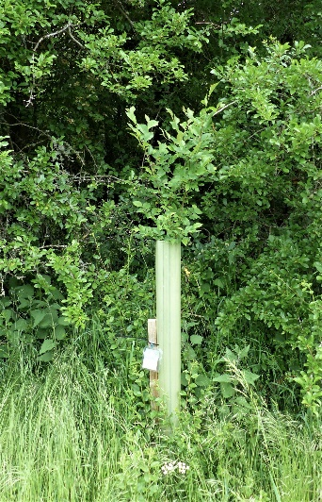I am pleased to report that the two disease-resistant elms that were planted by Upper Thames Valley branch of Butterfly Conservation at the Whitchurch Maze in February 2018 are growing well. It is hoped that they will provide additional food source for the colony of White-Letter Hairstreak butterflies that are known to live in this area (seen by Peter Cuss of BC in their larval stage on one of the 2 existing Wych elms growing in the Maze area). Here is a photo of one of the two trees taken today (we intend to prune back some of the encroaching branches behind it very soon!)
2. Finally, with the encouragement of Richard Wingfield, the editor of our Whitchurch village website, I have started writing some Nature Notes which are published online. The first one was on 1st April and since then, 3 subsequent issues. I am encouraging other people to contribute too. The feedback has been very positive. I try to make it easy to read but also informative, and well-illustrated. Jackie is kindly putting links to the articles on the PAWS website.

Sally Woolhouse, 10th May 2020